1. Complete the given below code, it is strictly recommended to define the member functions outside of the class and not to include any namespace in your code.

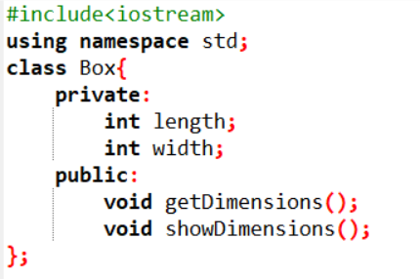

**box_1**

**box_2**

**box_n**

**Class**

**Objects**

#include <iostream>

class Box {

private:

int length;

int width;

public:

void getDimensions();

void showDimensions();

};

void Box::getDimensions() {

std::cout << "Enter length: ";

std::cin >> length;

std::cout << "Enter width: ";

std::cin >> width;

}

void Box::showDimensions() {

std::cout << "Length: " << length << std::endl;

std::cout << "Width: " << width << std::endl;

}

int main() {

Box box1, box2, box3;

std::cout << "For box1:" << std::endl;

box1.getDimensions();

box1.showDimensions();

std::cout << "\nFor box2:" << std::endl;

box2.getDimensions();

box2.showDimensions();

std::cout << "\nFor box3:" << std::endl;

box3.getDimensions();

box3.showDimensions();

return 0;

}

* We have defined the **Box** class with private members **length** and **width**.
* The **getDimensions()** member function prompts the user to enter the length and width of the box and stores the values in the respective data members.
* The **showDimensions()** member function displays the length and width of the box.
* Member function definitions are provided outside of the class.
* In the **main()** function, we create three objects of the **Box** class (**box1**, **box2**, **box3**), and then call the **getDimensions()** and **showDimensions()** functions for each object to get and display their dimensions.

2.Complete the given code snippet which contains two data members e.g**. principal and time** which are mapped with objects and one data member, **interest** which is not mapped with any of the object.

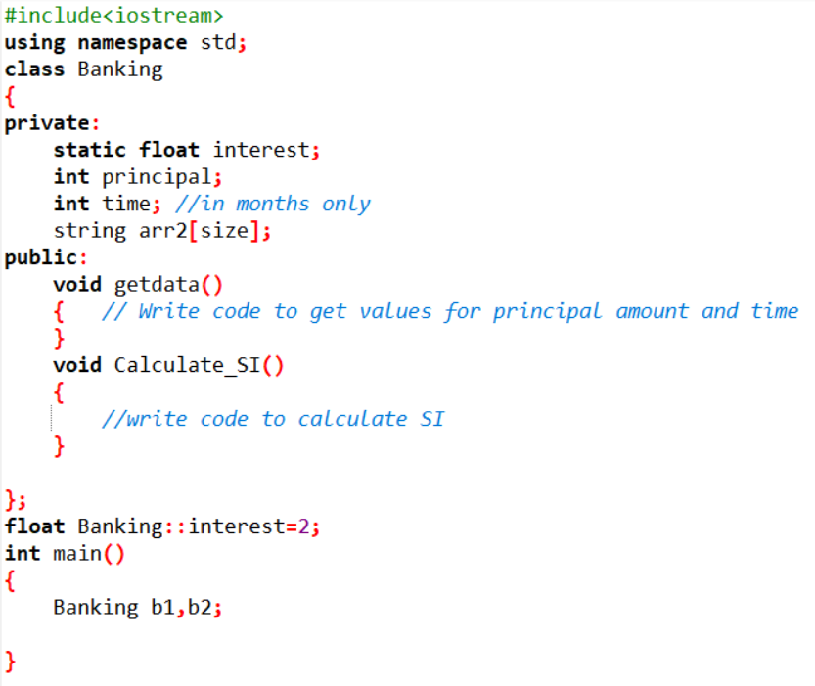

#include<iostream>

using namespace std;

class Banking {

private:

static float interest;

int principal;

int time; // in months only

public:

void getdata() {

cout << "Enter principal amount: ";

cin >> principal;

cout << "Enter time (in months): ";

cin >> time;

}

void Calculate_SI() {

float simpleInterest = (principal * interest * time) / 100.0;

cout << "Simple Interest: " << simpleInterest << endl;

}

};

float Banking::interest = 2; // Initializing static member interest

int main() {

Banking b1, b2;

cout << "For b1:" << endl;

b1.getdata(); // Getting data for b1

b1.Calculate_SI(); // Calculating and displaying simple interest for b1

cout << "\nFor b2:" << endl;

b2.getdata(); // Getting data for b2

b2.Calculate_SI(); // Calculating and displaying simple interest for b2

return 0;

}

3.Write a program in C++ which contains a class **Students**, two members member function with same name (signature of the function may be different) to get and display the details of the student as given below:

Name (character array)

Marks (for five subjects)

Grade (>80%: E, 70-80%: A, 60-70%: B, 50-60%: C and less than 50%: F)

#include <iostream>

#include <cstring>

class Students {

private:

char name[50];

int marks[5];

// Function to calculate grade based on marks

char calculateGrade(int mark) {

if (mark > 80)

return 'E';

else if (mark >= 70 && mark <= 80)

return 'A';

else if (mark >= 60 && mark < 70)

return 'B';

else if (mark >= 50 && mark < 60)

return 'C';

else

return 'F';

}

public:

// Member function to set student details

void setDetails(const char* studentName, const int studentMarks[5]) {

strcpy(name, studentName);

for (int i = 0; i < 5; ++i) {

marks[i] = studentMarks[i];

}

}

// Member function to display student details

void displayDetails() {

std::cout << "Name: " << name << std::endl;

std::cout << "Marks:\n";

for (int i = 0; i < 5; ++i) {

std::cout << "Subject " << (i+1) << ": " << marks[i] << std::endl;

}

std::cout << "Grade:\n";

for (int i = 0; i < 5; ++i) {

std::cout << "Subject " << (i+1) << ": " << calculateGrade(marks[i]) << std::endl;

}

}

};

int main() {

Students student1;

const char name[] = "John";

int marks[] = {85, 72, 60, 55, 40}; // Sample marks for five subjects

student1.setDetails(name, marks);

student1.displayDetails();

return 0;

}

4..Write a program in C++ with one member function to accept five integers from 0 to 9 and another function to display the equivalent values in word as shown below. The converted values should be stored in one of the member variables.

**Input**

|  |  |  |  |  |
| --- | --- | --- | --- | --- |
| **2** | **4** | **0** | **1** | **7** |

**Output**

|  |  |  |  |  |
| --- | --- | --- | --- | --- |
| **Two** | **Four** | **Zero** | **One** | **Seven** |

#include <iostream>

#include <string>

class NumberConverter {

private:

int numbers[5];

std::string words[5];

// Function to convert integer to word

std::string convertToWord(int num) {

switch (num) {

case 0:

return "Zero";

case 1:

return "One";

case 2:

return "Two";

case 3:

return "Three";

case 4:

return "Four";

case 5:

return "Five";

case 6:

return "Six";

case 7:

return "Seven";

case 8:

return "Eight";

case 9:

return "Nine";

default:

return "Invalid";

}

}

public:

// Member function to accept five integers and convert them to words

void acceptNumbers(int num1, int num2, int num3, int num4, int num5) {

numbers[0] = num1;

numbers[1] = num2;

numbers[2] = num3;

numbers[3] = num4;

numbers[4] = num5;

for (int i = 0; i < 5; ++i) {

words[i] = convertToWord(numbers[i]);

}

}

// Member function to display the equivalent values in words

void displayWords() {

for (int i = 0; i < 5; ++i) {

std::cout << words[i] << " ";

}

std::cout << std::endl;

}

};

int main() {

NumberConverter converter;

converter.acceptNumbers(2, 4, 0, 1, 7);

std::cout << "Output: ";

converter.displayWords();

return 0;

}

5.Create your own header file named as Find_Calculation which consists of three important functions that accepts and return double value(s) to compute the square root, cube and power of integer values respectively. Add this library in your C++ code and call these functions to perform the mathematical calculations.

Note: Students are not allowed to use the readymade functions

To create your own header file named "Find_Calculation" which consists of three functions to compute the square root, cube, and power of integer values, and then call these functions in your C++ code, you can follow these steps.

Step 1: Create a header file named "Find_Calculation.h" and define the function prototypes inside it.

Cpp1

// Find_Calculation.h

#ifndef FIND_CALCULATION_H

#define FIND_CALCULATION_H

double find_Sqrt(double value);

double find_Cube(double value);

double find_Pow(double base, double exponent);

#endif

Step 2: Implement the functions in a corresponding source file, for example, "Find_Calculation.cpp".

Cpp2

// Find_Calculation.cpp

#include "Find_Calculation.h"

double find_Sqrt(double value) {

double epsilon = 1e-10;

double guess = value / 2.0;

while (abs(guess * guess - value) > epsilon) {

guess = (guess + value / guess) / 2.0;

}

return guess;

}

double find_Cube(double value) {

return value * value * value;

}

double find_Pow(double base, double exponent) {

double result = 1.0;

for (int i = 0; i < exponent; ++i) {

result *= base;

}

return result;

}

Step 3: Include the header file in your C++ code where you want to use these functions and call them accordingly.

Cpp3

// YourMain.cpp

#include <iostream>

#include "Find_Calculation.h"

int main() {

double n1, n2, result;

std::cout << "Enter a number: ";

std::cin >> n1;

// Calculate and display square root

result = find_Sqrt(n1);

std::cout << "Square root of " << n1 << " is: " << result << std::endl;

// Calculate and display cube

result = find_Cube(n1);

std::cout << "Cube of " << n1 << " is: " << result << std::endl;

std::cout << "Enter another number: ";

std::cin >> n2;

// Calculate and display power

result = find_Pow(n1, n2);

std::cout << n1 << " raised to the power " << n2 << " is: " << result << std::endl;

return 0;

}

Ensure that "Find_Calculation.h", "Find_Calculation.cpp", and "YourMain.cpp" are in the same directory when you compile and run the code. This way, you have created your own header file named "Find_Calculation" containing three functions to compute square root, cube, and power of integer values, and used them in your C++ code.